3. Write a C program to find Factorial of a given number without using Recursion

**Aim:**To write a C program to calculate the factorial of a given number **without using recursion**.

**Algorithm**

1. Start the program.
2. Declare variables: n for the number, fact for storing the factorial (initialize fact = 1).
3. Read the number n from the user.
4. If n == 0 or n == 1, factorial is 1.
5. Otherwise, use a for loop from 1 to n:
   * Multiply fact = fact * i.
6. Print the factorial result.
7. Stop the program.

**Program:**

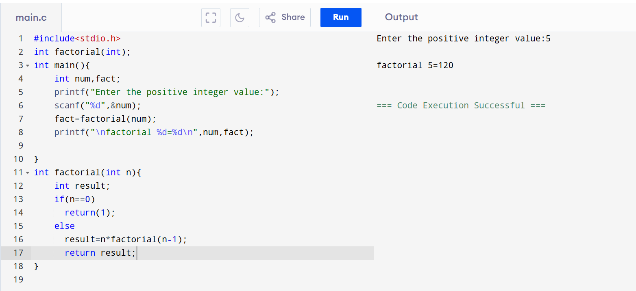

**Result:** Thus, the C program to calculate the factorial of a number without using recursion was successfully executed.